

**CAPSTONE PROJECT 1**

**DEMARK - DECENTRALIZED MARKET**

Sprint Backlog Document

Version: 1.1

CODE: DEMARK-1.0

**Mentor:** Man Nguyen Duc

**Team member:**

Ha Truong Van

Dat Ngo Ha Van

Nhan Vo Hoang Quoc

Phuong Tran Nhat

# **Project Information**

|  |  |  |  |  |  |
| --- | --- | --- | --- | --- | --- |
| **Project acronym** | DEMARK | | | | |
| **Project Title** | Demark - Decentralized Market | | | | |
| **Start Date** | Aug 31, 2018 | **End Date** | | Dec 10, 2018 | |
| **Lead Institution** | International School, Duy Tan University | | | | |
| **Project Mentor & contact details** | Man Nguyen Duc  Email: mannd@duytan.edu.vn  Tel: 0904 235 945 | | | | |
| **Product Owner** | Ha Truong Van | | | | |
| **Scrum Master** | Phuong Tran Nhat | | | | |
| **Team members** | **Name** | | **Email** | | **Tel** |
| Ha Truong Van | | vanha30111997@gmail.com | | 0969356097 |
| Dat Ngo Ha Van | | ngohavandat93ndc@gmail.com | | 01288446176 |
| Nhan Vo Hoang Quoc | | quocnhan810@gmail.com | | 01674559527 |
| Phuong Tran Nhat | | nhatphuongb1@gmail.com | | 01692502010 |

**Project Plan Document**

|  |  |  |  |
| --- | --- | --- | --- |
| **Document Title** | Sprint Backlog Document | | |
| **Reporting Period** | September 10, 2018 | | |
| **Team Information** | **Name** | **Role** |  |
| Nhan Vo Hoang Quoc | Team member |  |
| Ha Truong Van | Product owner & team member |  |
| Dat Ngo Ha Van | Team member |  |
| Phuong Tran Nhat | Scrum master & Team member |  |
| **Date** | September 10, 2018 | **Filename** | * DEMARK_SPRINT_BACKLOG_1.1.docx |
| **Access** | Project and Duy Tan University Program | |  |

# **Document History**

|  |  |  |  |
| --- | --- | --- | --- |
|  |  | Document History |  |
| **Version** | **Date** | **Comments** |  |
| 1.0 | Sep 10, 2018 | * Draft of document |  |
| 1.1. | Dec 10, 2018 | * Official document |  |

# **Document Approvals**

​The following signatures are required for approval of this document.

|  |  |  |
| --- | --- | --- |
| Man Nguyen Duc  *Mentor* |  | Date: |
| Ha Truong Van  *Product Owner* |  | Date: |
| Phuong Tran Nhat  *Scrum Master* |  | Date: |

Contents

**Project Information** 2

**Document History** 4

**Document Approvals** 4

1. **Sprint 1**

|  |  |  |  |  |  |  |
| --- | --- | --- | --- | --- | --- | --- |
| **Task** | **Responsible person** | **Estimated Point** | **Actual Point** | **Status** | **Start Date** | **End Date** |
| Exchange UI Design | Ha | 21 | 15 | Not Done | 24-Sep |  |
| Smart Contract Design | Nhan | 21 | 11 | Done | 24-Sep |  |
| Architect Design | Phuong | 21 | 13 | Not Done | 24-Sep |  |
| Project Plan | Phuong | 17 | 17 | Done | 24-Sep | 10/1/2018 |
| Database Design | Dat | 13 | 13 | Done | 24-Sep | 10/3/2018 |

|  |  |  |  |  |  |  |  |  |  |  |  |  |  |
| --- | --- | --- | --- | --- | --- | --- | --- | --- | --- | --- | --- | --- | --- |
| **Milestone** | 9/24 | 9/25 | 9/26 | 9/27 | 9/28 | 9/29 | 9/30 | 10/1 | 10/2 | 10/3 | 10/4 | 10/5 | 10/6 |
| **Estimated remaining point** | 93 | 85 | 78 | 70 | 62 | 55 | 47 | 40 | 32 | 24 | 17 | 9 | 0 |
| **Actual remaining point** | 93 | 87 | 79 | 71 | 63 | 56 | 51 | 43 | 38 | 33 | 30 | 27 | 24 |
| **Exchange UI Design** | 21 | 20 | 18 | 16 | 15 | 15 | 14 | 13 | 10 | 9 | 8 | 7 | 6 |
| **Smart Contract Design** | 21 | 20 | 18 | 17 | 16 | 16 | 15 | 14 | 14 | 13 | 12 | 11 | 10 |
| **Architect Design** | 21 | 19 | 18 | 18 | 16 | 15 | 14 | 13 | 12 | 11 | 10 | 9 | 8 |
| **Project Plan** | 17 | 15 | 13 | 10 | 7 | 5 | 3 | 0 | 0 | 0 | 0 | 0 | 0 |
| **Database Design** | 13 | 13 | 12 | 10 | 9 | 5 | 5 | 3 | 2 | 0 | 0 | 0 | 0 |

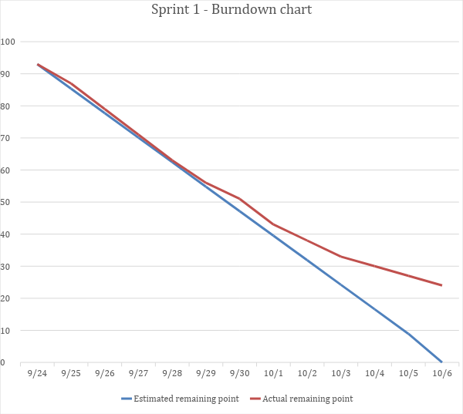

1. **Sprint 2**

|  |  |  |  |  |  |  |
| --- | --- | --- | --- | --- | --- | --- |
| **Task** | **Responsible person** | **Estimated Point** | **Actual Point** | **Status** | **Start Date** | **End Date** |
| Exchange UI Design | Ha | 6 | 6 | Done | 24-Sep | 12-Oct |
| Architect Design | Phuong | 8 | 8 | Done | 24-Sep | 15-Oct |
| Smart Contract Design | Nhan | 10 | 8 | Not Done | 24-Sep |  |
| Request To Submit Token | Nhan | 21 | 10 | Not Done | 8-Oct |  |
| Submit token | Dat | 21 | 14 | Not Done | 8-Oct |  |
| View List Token | Ha | 21 | 14 | Not Done | 8-Oct |  |
| Sprint Document | Phuong | 7 | 7 | Done | 8-Oct | 21-Oct |

|  |  |  |  |  |  |  |  |  |  |  |  |  |  |  |
| --- | --- | --- | --- | --- | --- | --- | --- | --- | --- | --- | --- | --- | --- | --- |
| **Milestone** | 10/8 | 10/9 | 10/10 | 10/11 | 10/12 | 10/13 | 10/14 | 10/15 | 10/16 | 10/17 | 10/18 | 10/19 | 10/20 | 10/21 |
| **Estimated remaining point** | 94 | 87 | 79 | 72 | 65 | 58 | 50 | 43 | 36 | 29 | 21 | 14 | 7 | 0 |
| **Actual remaining point** | 94 | 91 | 86 | 83 | 76 | 68 | 63 | 57 | 53 | 46 | 43 | 37 | 32 | 27 |
| **Exchange UI Design** | 6 | 5 | 3 | 1 | 0 | 0 | 0 | 0 | 0 | 0 | 0 | 0 | 0 | 0 |
| **Architect Design** | 8 | 7 | 6 | 6 | 5 | 4 | 2 | 0 | 0 | 0 | 0 | 0 | 0 | 0 |
| **Smart Contract Design** | 10 | 9 | 8 | 8 | 8 | 7 | 7 | 6 | 6 | 6 | 6 | 5 | 4 | 2 |
| **Request to Submit Token** | 21 | 21 | 21 | 21 | 18 | 17 | 16 | 15 | 14 | 13 | 12 | 12 | 11 | 11 |
| **Submit token** | 21 | 21 | 20 | 19 | 17 | 16 | 15 | 14 | 13 | 12 | 12 | 10 | 9 | 7 |
| **View List Token** | 21 | 21 | 21 | 21 | 21 | 19 | 18 | 17 | 15 | 12 | 10 | 8 | 7 | 7 |
| **Sprint Document** | 7 | 7 | 7 | 7 | 7 | 5 | 5 | 5 | 5 | 3 | 3 | 2 | 1 | 0 |

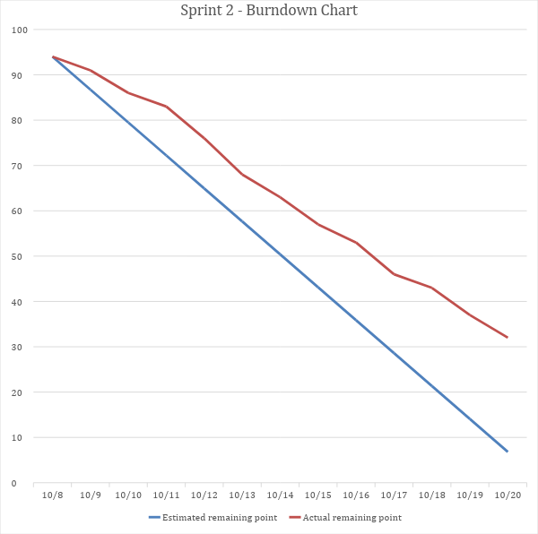

1. **Sprint 3**

|  |  |  |  |  |  |  |
| --- | --- | --- | --- | --- | --- | --- |
| **Task** | **Responsible person** | **Estimated Point** | **Actual Point** | **Status** | **Start Date** | **End Date** |
| Smart Contract Design | Nhan | 2 | 2 | Done | 24-Sep | 27-Oct |
| Request to Submit Token | Nhan | 11 | 7 | Not Done | 8-Oct |  |
| Submit token | Dat | 7 | 7 | Done | 8-Oct | 30-Oct |
| View List Token | Ha | 7 | 7 | Done | 8-Oct | 30-Oct |
| Sprint Document | Phuong | 13 | 13 | Done | 23-Oct | 2-Nov |
| User's Balance | Ha | 21 | 8 | Not Done | 23-Oct |  |

|  |  |  |  |  |  |  |  |  |  |  |  |  |  |
| --- | --- | --- | --- | --- | --- | --- | --- | --- | --- | --- | --- | --- | --- |
| **Milestone** | 10/23 | 10/24 | 10/25 | 10/26 | 10/27 | 10/28 | 10/29 | 10/30 | 10/31 | 11/1 | 11/2 | 11/3 | 11/4 |
| **Estimated remaining point** | 61 | 56 | 51 | 46 | 41 | 36 | 31 | 26 | 20 | 15 | 10 | 5 | 0 |
| **Actual remaining point** | 61 | 58 | 52 | 48 | 43 | 39 | 34 | 28 | 25 | 23 | 20 | 19 | 17 |
| **Smart Contract Design** | 2 | 2 | 1 | 1 | 0 | 0 | 0 | 0 | 0 | 0 | 0 | 0 | 0 |
| **Request to Submit Token** | 11 | 11 | 11 | 11 | 11 | 9 | 7 | 6 | 5 | 4 | 4 | 4 | 4 |
| **Submit token** | 7 | 6 | 5 | 4 | 4 | 3 | 2 | 0 | 0 | 0 | 0 | 0 | 0 |
| **View List Token** | 7 | 6 | 5 | 5 | 4 | 3 | 2 | 0 | 0 | 0 | 0 | 0 | 0 |
| **Sprint Document** | 13 | 12 | 9 | 6 | 3 | 3 | 2 | 1 | 1 | 1 | 0 | 0 | 0 |
| **User's Balance** | 21 | 21 | 21 | 21 | 21 | 21 | 21 | 21 | 19 | 18 | 16 | 15 | 13 |

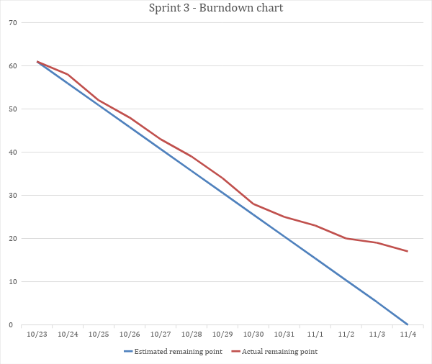

1. **Sprint 4**

|  |  |  |  |  |  |  |
| --- | --- | --- | --- | --- | --- | --- |
| **Task** | **Responsible person** | **Estimated Point** | **Actual Point** | **Status** | **Start Date** | **End Date** |
| Sprint Document | Phuong | 13 | 13 | Done | 23-Oct | 18-Nov |
| Request to Submit Token | Nhan | 4 | 4 | Done | 8-Oct | 9-Nov |
| View List Token | Ha | 3 | 3 | Done | 10-Oct | 8-Nov |
| Deposit | Nhan | 21 | 21 | Done | 23-Oct | 18-Nov |
| Token Detail | Dat | 21 | 21 | Done | 23-Oct | 18-Nov |
| User's Balance | Ha | 13 | 13 | Done | 23-Oct | 11-Nov |

|  |  |  |  |  |  |  |  |  |  |  |  |  |  |  |
| --- | --- | --- | --- | --- | --- | --- | --- | --- | --- | --- | --- | --- | --- | --- |
| **Milestone** | 11/6 | 11/7 | 11/8 | 11/9 | 11/10 | 11/11 | 11/12 | 11/13 | 11/14 | 11/15 | 11/16 | 11/17 | 11/18 | 11/19 |
| **Estimated remaining point** | 75 | 69 | 63 | 57 | 51 | 45 | 39 | 33 | 27 | 21 | 15 | 9 | 3 | 0 |
| **Actual remaining point** | 75 | 68 | 60 | 51 | 45 | 38 | 32 | 28 | 22 | 17 | 14 | 11 | 6 | 0 |
| **Sprint Document** | 13 | 11 | 9 | 7 | 6 | 5 | 3 | 2 | 1 | 1 | 1 | 1 | 1 | 0 |
| **Request to Submit Token** | 4 | 3 | 2 | 0 | 0 | 0 | 0 | 0 | 0 | 0 | 0 | 0 | 0 | 0 |
| **View List Token** | 3 | 2 | 0 | 0 | 0 | 0 | 0 | 0 | 0 | 0 | 0 | 0 | 0 | 0 |
| **Deposit** | 21 | 21 | 21 | 18 | 16 | 15 | 14 | 13 | 9 | 8 | 7 | 5 | 2 | 0 |
| **Token Detail** | 21 | 21 | 21 | 21 | 21 | 18 | 15 | 13 | 12 | 8 | 6 | 5 | 3 | 0 |
| **User's Balance** | 13 | 10 | 7 | 5 | 2 | 0 | 0 | 0 | 0 | 0 | 0 | 0 | 0 | 0 |

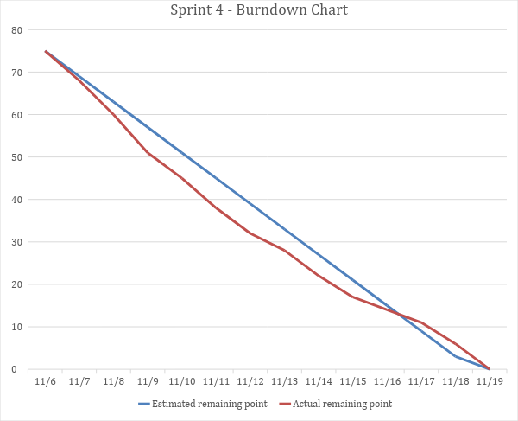

1. **Sprint 5**

|  |  |  |  |  |  |  |
| --- | --- | --- | --- | --- | --- | --- |
| **Task** | **Responsible person** | **Estimated Point** | **Actual Point** | **Status** | **Start Date** | **End Date** |
| Transaction History | Ha | 21 | 9 | Not Done | 21-Nov |  |
| Transfer | Dat | 21 | 12 | Not Done | 21-Nov |  |
| Withdraw | Nhan | 21 | 7 | Not Done | 21-Nov |  |
| Buy Token | Nhan | 21 | 8 | Not Done | 21-Nov |  |
| Reward | Ha | 21 | 9 | Not Done | 21-Nov |  |
| Sprint Document | Phuong | 13 | 13 | Done | 21-Nov | 3-Dec |

|  |  |  |  |  |  |  |  |  |  |  |  |  |  |
| --- | --- | --- | --- | --- | --- | --- | --- | --- | --- | --- | --- | --- | --- |
| **Milestone** | 11/21 | 11/22 | 11/23 | 11/24 | 11/25 | 11/26 | 11/27 | 11/28 | 11/29 | 11/30 | 12/1 | 12/2 | 12/3 |
| **Estimated remaining point** | 118 | 109 | 99 | 90 | 80 | 71 | 61 | 52 | 43 | 33 | 24 | 14 | 0 |
| **Actual remaining point** | 118 | 108 | 95 | 89 | 84 | 80 | 77 | 71 | 68 | 66 | 64 | 63 | 60 |
| **Transaction History** | 21 | 19 | 17 | 17 | 16 | 16 | 15 | 15 | 14 | 14 | 13 | 13 | 12 |
| **Transfer** | 21 | 20 | 19 | 18 | 17 | 16 | 15 | 14 | 13 | 12 | 11 | 10 | 9 |
| **Withdraw** | 21 | 19 | 17 | 17 | 17 | 17 | 17 | 14 | 14 | 14 | 14 | 14 | 14 |
| **Buy Token** | 21 | 18 | 15 | 13 | 13 | 13 | 13 | 13 | 13 | 13 | 13 | 13 | 13 |
| **Reward** | 21 | 19 | 17 | 15 | 14 | 12 | 12 | 12 | 12 | 12 | 12 | 12 | 12 |
| **Sprint Document** | 13 | 13 | 10 | 9 | 7 | 6 | 5 | 3 | 2 | 1 | 1 | 1 | 0 |

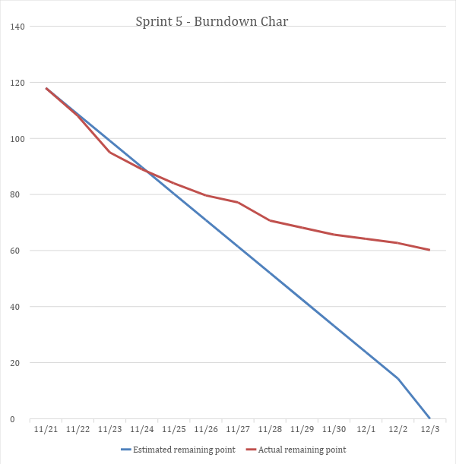

1. **Sprint 6**

|  |  |  |  |  |  |  |
| --- | --- | --- | --- | --- | --- | --- |
| **Task** | **Responsible person** | **Estimated Point** | **Actual Point** | **Status** | **Start Date** | **End Date** |
| Transaction History | Ha | 12 |  | Not Done | 24-Nov | 9-Dec |
| Transfer | Dat | 9 |  | Not Done | 25-Nov | 9-Dec |
| Withdraw | Nhan | 14 |  | Not Done | 26-Nov | 9-Dec |
| Buy Token | Nhan | 13 |  | Not Done | 27-Nov | 10-Dec |
| Reward | Ha | 12 |  | Not Done | 28-Nov | 10-Dec |
| Sprint Document | Phuong | 13 |  | Not Done | 4-Dec | 10-Dec |

|  |  |  |  |  |  |  |  |
| --- | --- | --- | --- | --- | --- | --- | --- |
| **Milestone** | 12/4 | 12/5 | 12/6 | 12/7 | 12/8 | 12/9 | 12/10 |
| **Estimated remaining point** | 73 | 58 | 44 | 29 | 23 | 8 | 0 |
| **Actual remaining point** | 73 | 59 | 44 | 33 | 23 | 6 | 0 |
| **Transaction History** | 12 | 10 | 9 | 7 | 5 | 0 | 0 |
| **Transfer** | 9 | 7 | 5 | 4 | 2 | 0 | 0 |
| **Withdraw** | 14 | 12 | 6 | 4 | 2 | 0 | 0 |
| **Buy Token** | 13 | 10 | 8 | 6 | 5 | 3 | 0 |
| **Reward** | 12 | 10 | 9 | 6 | 5 | 2 | 0 |
| **Sprint Document** | 13 | 10 | 7 | 6 | 4 | 1 | 0 |

